On load Look and feel of the UI.

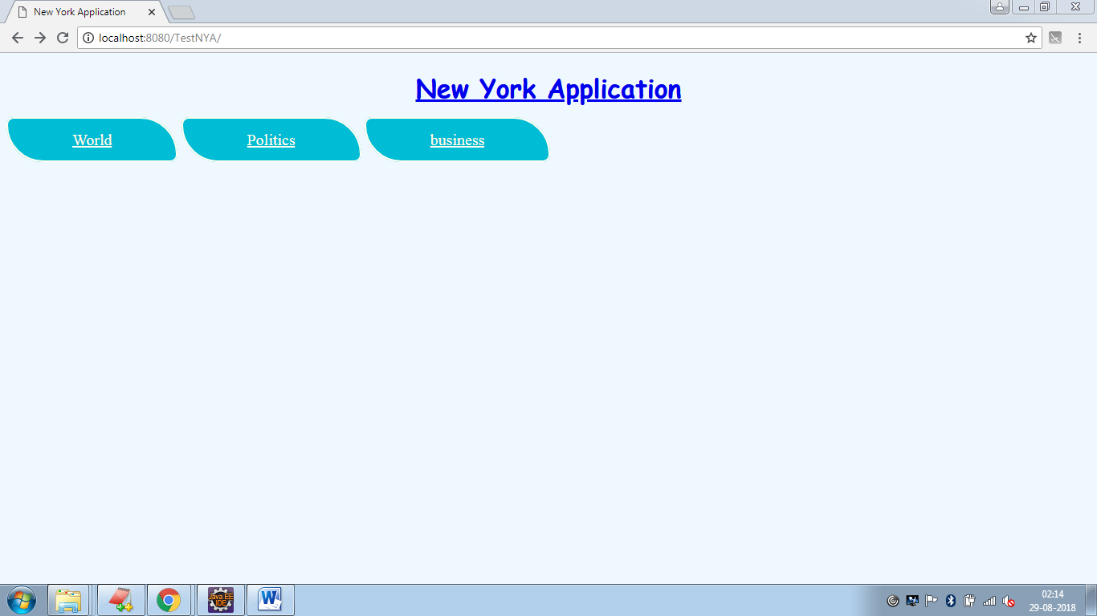

Fig.1. Look and feel of the page during on load

On hover of any tab there will be change in color of the tab as shown.

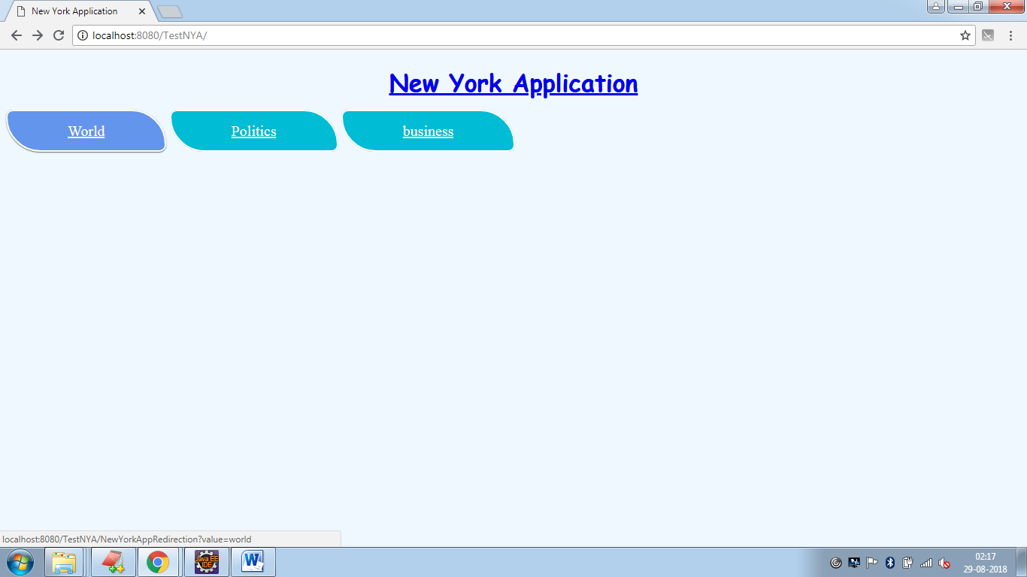

Fig.2. On hover change in tab color

On click of tab, redirecting to corresponding sections in New York Times website.

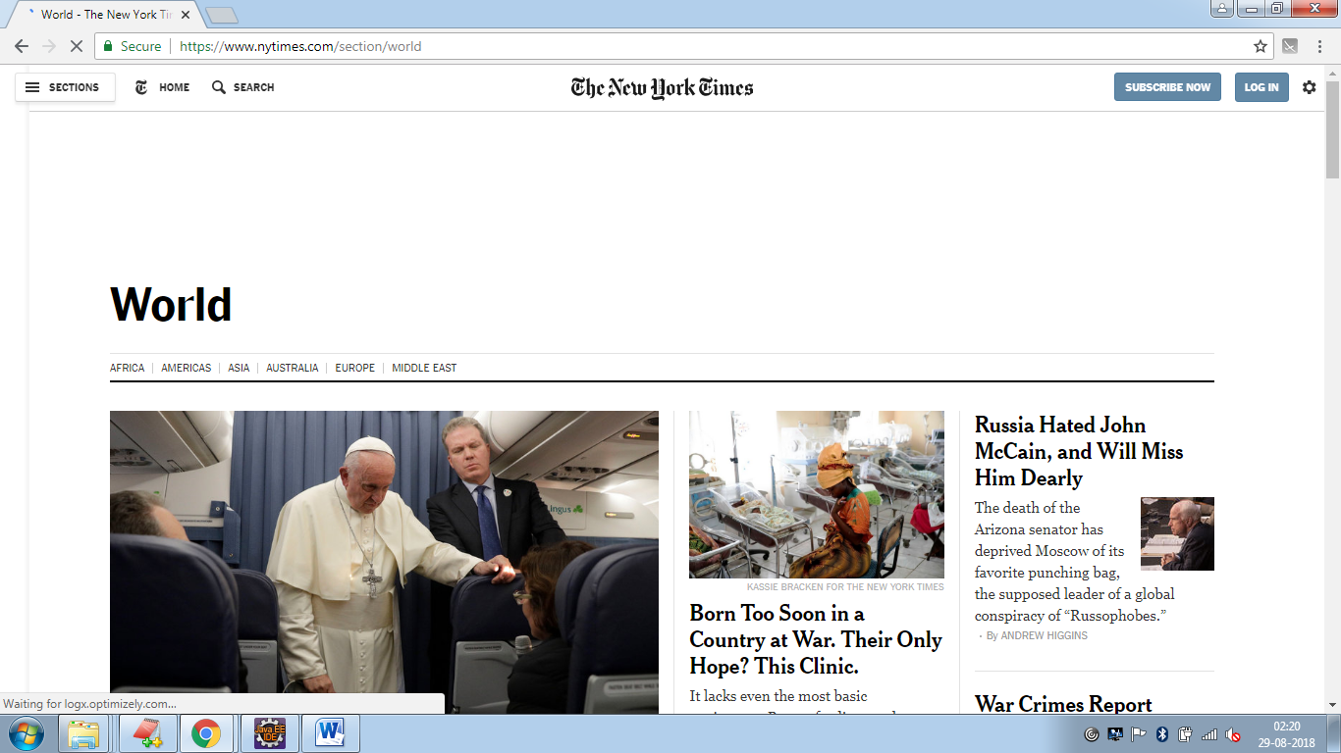

Fig.3. Redirection from the New York Application to website